## **Creating an OLTP database structure**

### **1.1 Creating a database “OLTP_OnlineCourses”**

1. Open **pgAdmin**.

2. Create a new database named: **OLTP_OnlineCourses**.

### **1.2 Creating the basic OLTP schema**

1. Open the file create_oltp_schema.sql.
2. Run the **entire script** in the database OLTP_OnlineCourses.

After the execution, you should have the following **9 tables**:

1) Users  
2) Categories  
3) Course  
4) Records  
5) Rating  
6) Certificate  
7) Payment  
8) Instructors  
9) Course_Instructors

### **1.3 Preparing temporary tables and uploading data**

1. Open the file load_csv_to_oltp.sql.
2. Execute **the part of the script** that contains only **CREATE TABLE** for temporary tables:
3. CREATE TABLE temp_users (...);
4. CREATE TABLE temp_categories_and_courses (...);
5. CREATE TABLE temp_records_and_ratings (...);
6. CREATE TABLE temp_cert_pay (...);
7. CREATE TABLE temp_instructors (...);

After completion, **5 more temporary tables** will be added, and the total number of tables will be **14**.

## 

## **Step 2: Import data from CSV**

### **2.1 Import CSV files into the corresponding temporary tables** (all *.csv files are located in the OnlineCourses_scv_files folder)

Go to:

**OLTP_OnlineCourses → Schemas → Tables**

For each table, follow these steps:

#### **temp_users**

Right click → **Import/Export Data**

In the Filename field, specify the file:  
 Untitled spreadsheet - Users (2).csv

Click **OK**

Then **everything is the same**, but for the rest of the tables :

#### **temp_categories_and_courses**

Select a file:  
 categories_and_courses (2).csv

#### 

#### 

#### **temp_records_and_ratings**

Select a file:  
 records_and_ratings.csv

#### **temp_cert_pay**

Select a file:  
 certificates_and_payments.csv

#### **temp_instructors**

Select a file:  
 Instructors (2).csv

**Step 3: Loading data from temporary tables to main tables**

Now, after the data has been loaded into the temporary tables, we can insert them into the main tables.

**For this :**

1. Run the rest of the INSERT INTO table_name script.

The data has now been uploaded to the main tables.

**Step 4: OLAP and ETL**

Open the file olap_setup.sql.

In order to connect to the existing OLTP database “OLTP_OnlineCourses” and retrieve the data from there, you need this part of the script :

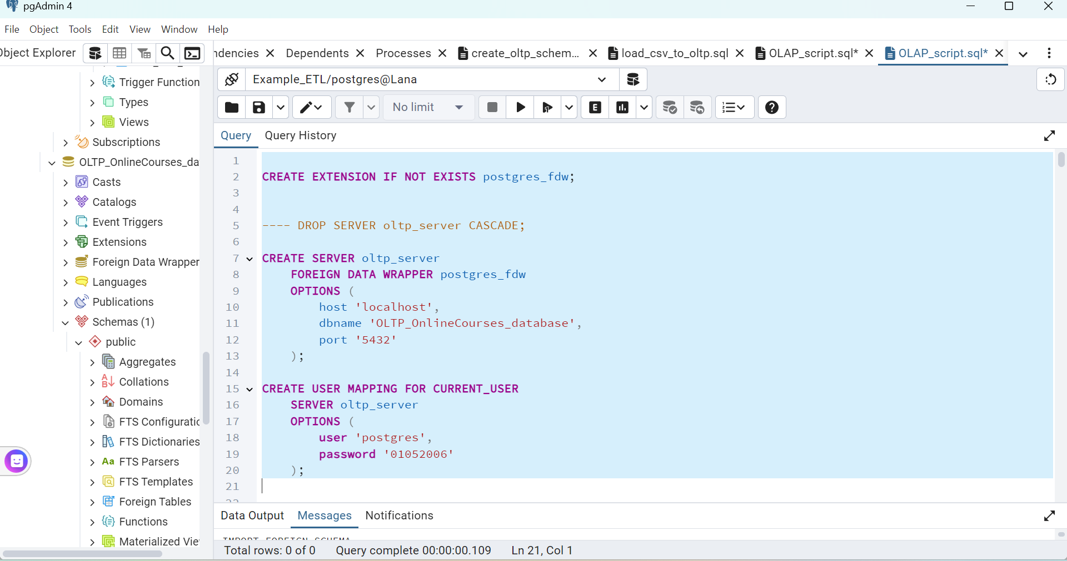

**2. Import tables from the OLTP database**

Next, we import the tables, for this we execute this part of the script :

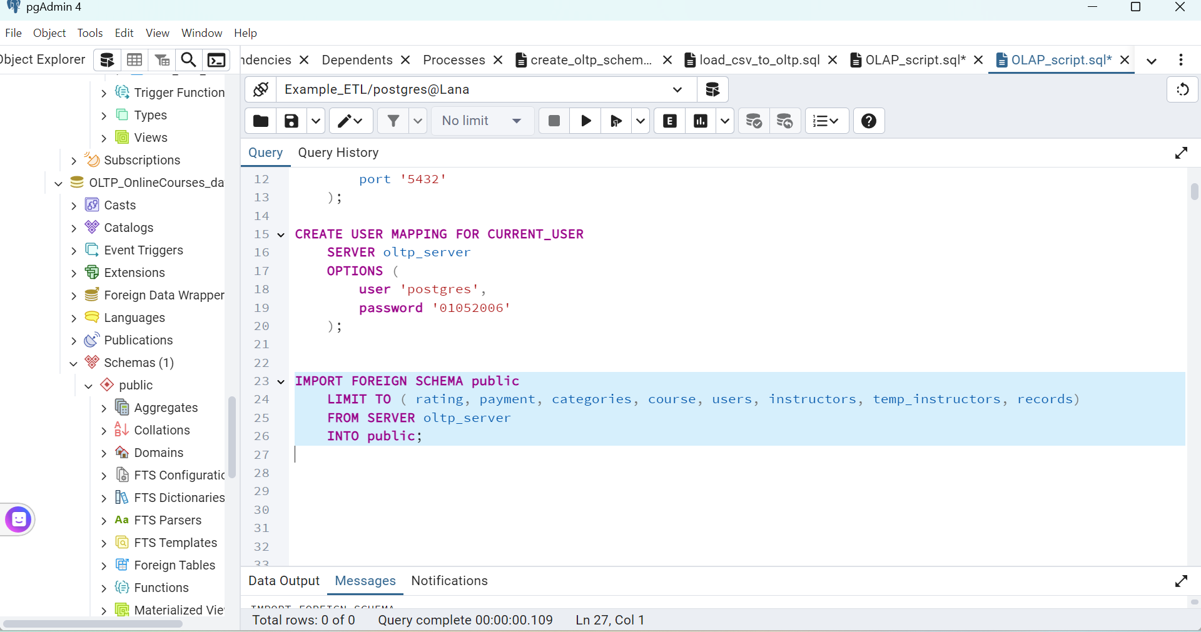

**3. Creating and uploading dimensions**

Open the file olap_schema.sql

And we execute this part of the script :

**dwh_Dim_Time**

CREATE TABLE dwh_Dim_Time (...);

**dwh_Dim_Category**

CREATE TABLE dwh_Dim_Category (...);

**dwh_Dim_Course**

CREATE TABLE dwh_Dim_Course (...);

**dwh_Dim_User ( SCD Type 2 )**

CREATE TABLE dwh_Dim_User (...);

**dwh_Dim_Instructor**

CREATE TABLE dwh_Dim_Instructor (...);

**4. Creating and loading a bridge table**

To create a linking table, run this part of the script :

dwh_Bridge_Instructor_Course (Connection of courses and instructors)

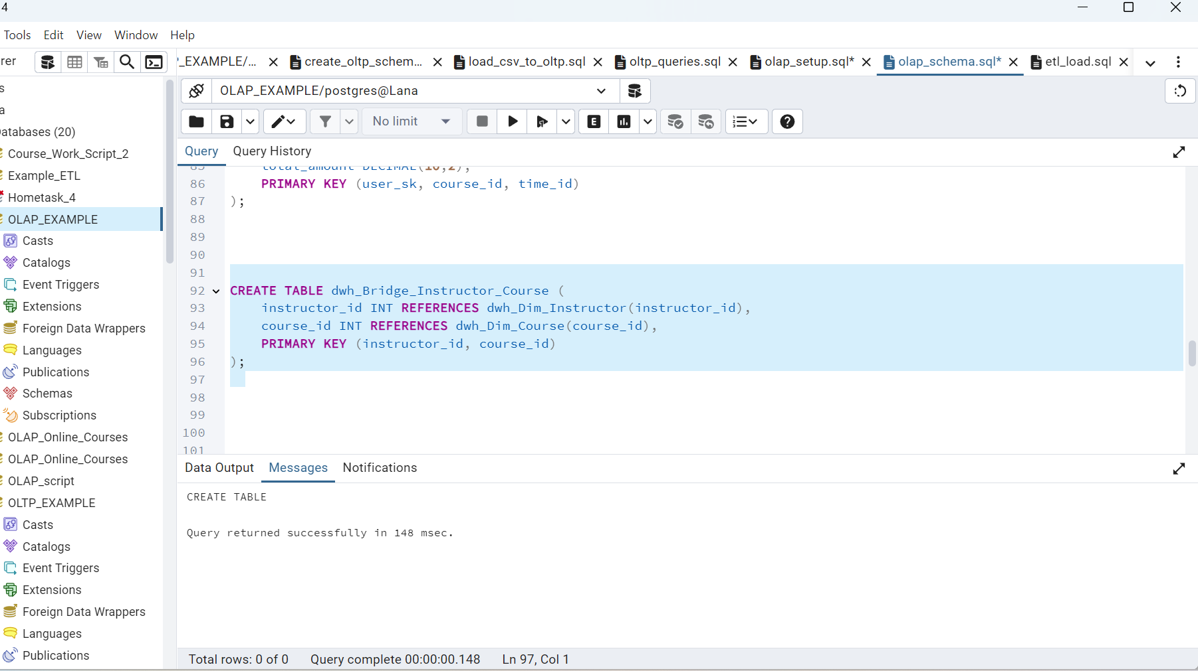

**5. Creating fact tables**

1. **dwh_Fact_Rating** (The fact of the ratings), **dwh_Fact_Enrollment** (The fact of enrolling in courses) and **dwh_Fact_Payment** (The fact of payments)

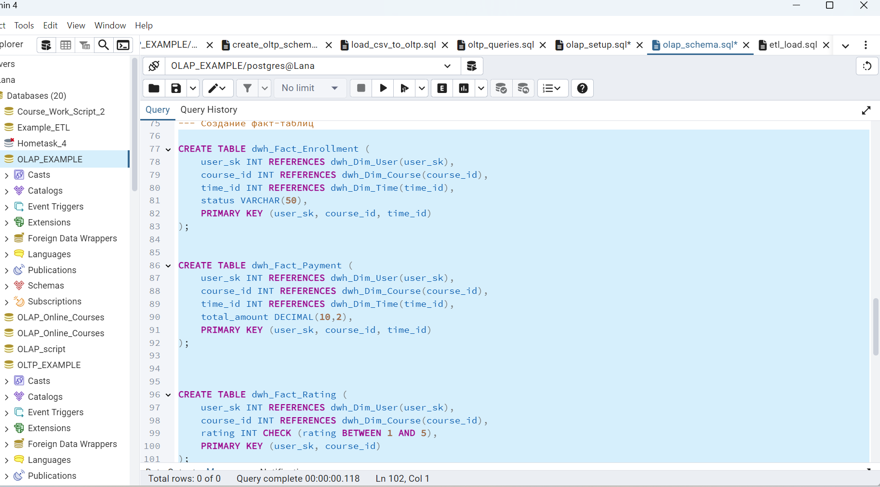

**6. Creating aggregates (materialized views)**

1. Monthly payments:

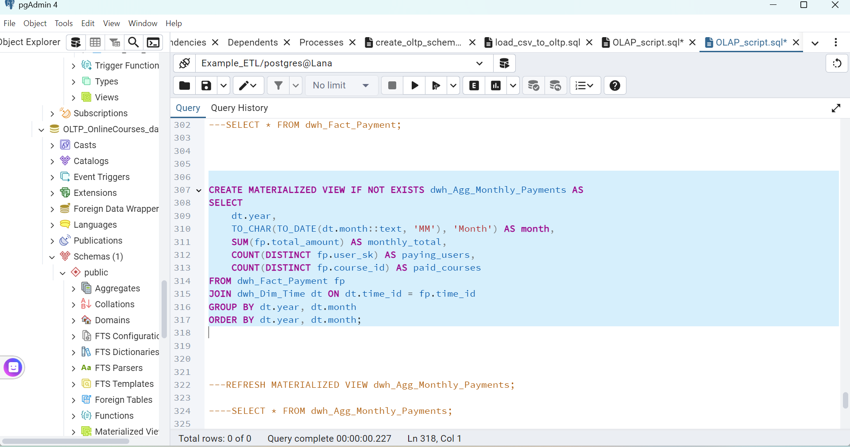

1. Average course grade :

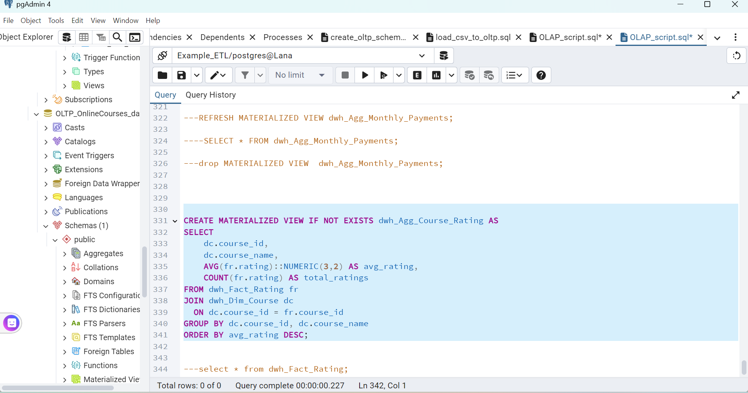

**Step 5: Download the data**

1. Open the file etl_load.sql

Uploading data to **Dimension Tables**

To do this, run this part of the script :

**INSERT INTO dwh_Dim_Time** — dates from the Payment table, with extraction of the day, month, quarter, and year.

**INSERT INTO dwh_Dim_Category** — unique categories from the Categories table.

**INSERT INTO dwh_Dim_Course** — courses linked to categories.

**INSERT INTO dwh_Dim_User** — users with SCD Type 2 support (tracking changes by name and email fields).

**INSERT INTO dwh_Dim_Instructor** — instructors.

**INSERT INTO dwh_Bridge_Instructor_Course** — a bridge table between courses and teachers.

All inserts were made only for new records using **NOT EXISTS** or **NOT IN** to avoid duplication.

Next, upload the data to the **Fact Tables**

**INSERT INTO dwh_Fact_Rating**

**INSERT INTO dwh_Fact_Enrollment**

**INSERT INTO dwh_Fact_Payment**

When inserting into the fact tables, **JOINS** were applied to the dimensions and checking for the absence of duplicate records **(NOT EXISTS)**.

**DISTINCT** was also used in certain places to avoid mistakes when violating unique restrictions.